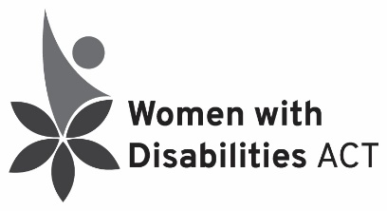
Guide to the Convention on the Rights of Persons with Disabilities (CRPD)

The Convention on the Rights of Persons with Disabilities (CRPD) is a human rights treaty to protect the rights and dignity of people with disabilities. Australia ratified the convention in 2008. The CRPD is the most recent UN Human Rights Convention. Australia was the 22nd signatory country.
Countries that sign the CRPD are called “States Parties”. Each States Party puts in place laws to help people with disabilities enjoy all human rights and fundamental freedoms on an equal basis with their peers.
Focus Areas
The articles of the CRPD tell States Parties to focus on certain problems. This means they need to make laws to protect the rights of people with disabilities in these areas. Some of them include:
- Equity for women and children with disability
- Accessible infrastructure
- Equal recognition before the law and access to justice
- Freedom from torture, cruelty, violence and abuse
- Independent living and inclusion in the community
- Freedom of expression and access to information
- Respect for privacy and personal liberty
- Respect for home and family, including the right to marry and have children
- The right to education, health care and work
- The right to an adequate standard of living
- Participation in political and public life, culture and recreation
State Parties commit to international cooperation and to ensure that the CRPD is upheld in international development programs.

State Parties have to report to the CRPD Committee on progress with implementation of the Convention at the UN in New York about every 4 years. Civil Society Organisations put in parallel reports on progress.
The Optional Protocol
The CRPD has an Optional Protocol that allows people to complain directly to the UN about their country if it is violating their rights. The UN can then investigate those claims. Australia ratified this protocol in 2009.
For more information go to: https://www.humanrights.gov.au/our-work/disability-rights/international/united-nations-convention-rights-persons-disabilities
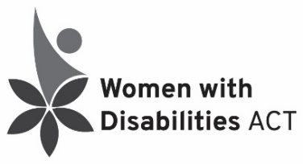
Guide to the Convention on the Elimination of (All Forms of) Discrimination against Women (CEDAW)

The Convention on the Elimination of (All Forms of) Discrimination Against Women (CEDAW) is an international treaty that says countries need to eliminate gender-based discrimination. Australia ratified CEDAW in 1983. The Australian Sex Discrimination Act, passed in 1984, embodies many CEDAW rights. CEDAW States that women have these rights:
Economic Rights
- Equal access to family benefits, loans and credit
Social Rights
- Equal access to education and employment
- Equal access to health care and family planning
- Equal treatment for rural women
Cultural Rights
- Tells governments to stop cultural practices that discriminate against women
- Equal participation in recreational activities like sports
Civil Rights
- Equality in legal matters
- The right to freedom of movement
- The right to choose where they live
Political Rights
- The right to vote and hold office in politics
- The right to represent their government at an international level
Issues in Australia:
The Committee overseeing CEDAW found some issues in Australia in their 2018 report:
- Unacceptably high levels of violence against women
- Low levels of participation by women in politics and public life
- Poor enforcement of laws stopping discrimination
- Pay inequity
- Continued inequity of disadvantaged groups of women which include:
  - Aboriginal and Torres Strait Islander women
  - Women migrants, refugees and asylum seekers
  - Women with disabilities.
Optional Protocol
Australia ratified the Optional Protocol to CEDAW in 2008 on the 25th anniversary of ratifying the Convention itself.
For more information, go to https://www.humanrights.gov.au/convention-elimination-all-forms-discrimination-against-women-cedaw-sex-discrimination-international

