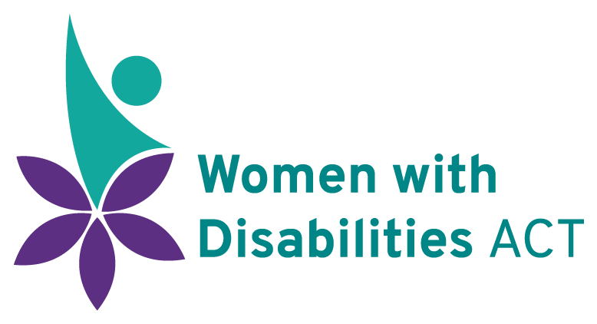

Our Advocacy

Women with Disabilities ACT (WWDACT) is Disabled Person’s Organisation (DPO) that practices systemic advocacy on behalf of women, girls, feminine identifying, and non-binary people with disabilities in the ACT. We follow a human rights philosophy, based on the Convention on the Rights of Persons with Disabilities (CRPD) and the Convention on the Elimination of All Forms of Discrimination Against Women (CEDAW).
Systemic Advocacy aims to create a more inclusive community through changes to legislation, policy, and practices. WWDACT uses systemic advocacy to protect and enforce the rights and interests of women* with disabilities in the ACT.

Systemic Advocacy
WWDACT’s advocacy seeks to:
- Produce long-term changes to systems that support and respond to the needs of women* with disabilities in the ACT.
- Ensure the rights and interests of women* with disabilities are upheld.
- Promote improved opportunities and outcomes for equitable participation in all areas of the community.
- Ensure local issues and experiences of individuals inform the focus of our work.

Our Members
Our members provide us with knowledge based in lived experience which helps us to:
- Identify areas of concern for women* with disabilities in the ACT.
- Identify problems that exist within ACT systems.
- Understand how recent international and national research applies (or does not apply) to our local context

How we Advocate
Our advocacy is also based on research, enquiries, reviews, and systems analysis. We approach systemic advocacy in several ways, including:
- Submissions to State Government inquiries and organisations
- Submissions to the Federal Government where there is a direct impact on women* with disabilities in the ACT
- Community awareness (e.g., through social media campaigns)
- Community Education (e.g., we support the production of educational material)
- Local Media Engagement (e.g., newspapers, television, radio, social media)

WWDACT frequently collaborates with other community-based organisations in the ACT, and freely share our research, information, and expertise.

WWDACT does not provide support or advocacy to individuals with disabilities or their families. If you need assistance with personal advocacy, we encourage you to contact Advocacy for Inclusion (AFI) or ACT Disability, Aged and Carer Advocacy Service (ADACAS). If you are a carer seeking support, you can also contact Carer’s ACT.

